7.26: a) & b)

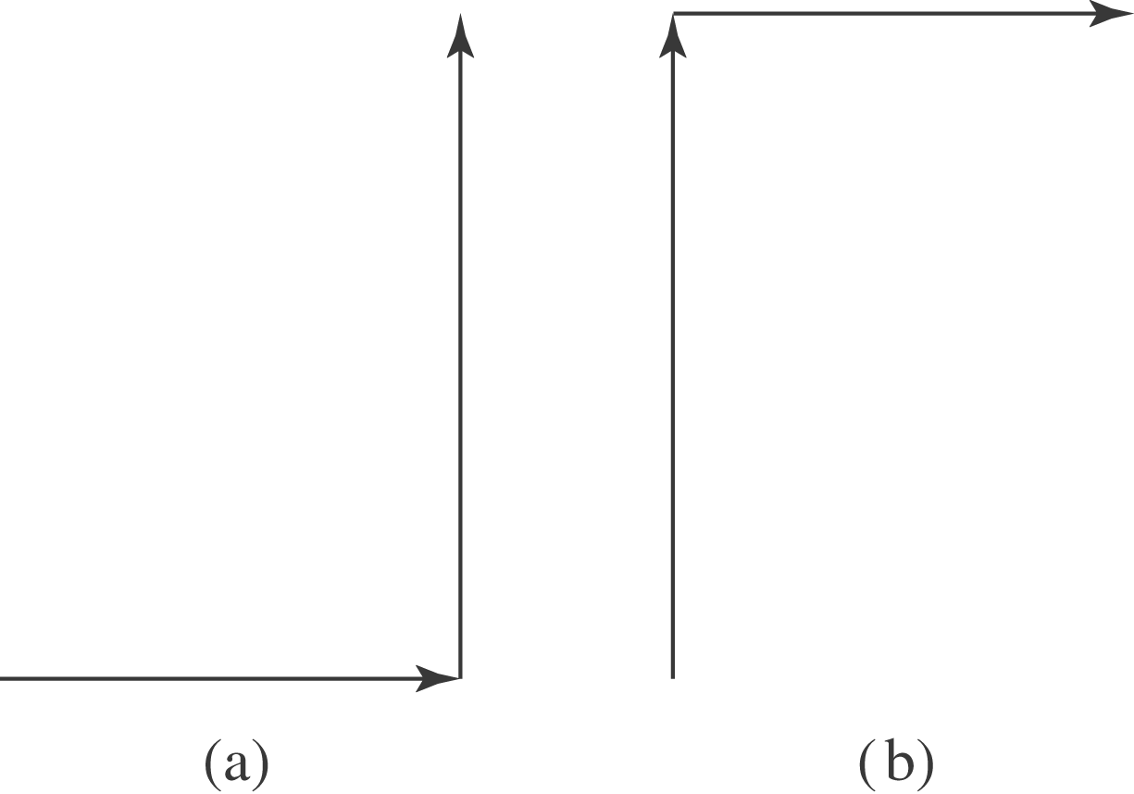

c) Gravity is conservative, as the work done to go from one point to another is path-independent.

